What is NoSQL Database?

**Before starting MongoDB,** we must know about NoSQL. NoSQL or “non-SQL” a non-structured database. It provides a facility for storage and retrieval of data using fields. While in SQL the data stores in a tabular form. Companies are using a NoSQL database in [**big data**](https://data-flair.training/blogs/what-is-big-data/)and real-time applications. NoSQL offers “eventual consistency” so that it may not meet the real-time application requirements. Still, its use to merits over relational databases.

What is MongoDB?

*MongoDB is an open source platform written in C++ and has*a very*easy setup environment*. It is a cross-platform, document-oriented and non-structured database. MongoDB provides high performance, high availability, and auto-scaling.

It is a NoSQL database and has flexibility with querying and [**indexing**](https://data-flair.training/blogs/mongodb-index/). MongoDB has very rich query language resulting in high performance.

MongoDB Features

Here, in this part of the MongoDB Tutorial, we discuss some key features of MongoDB:

i. Ad-hoc Queries

MongoDB supports ad-hoc queries by indexing.

ii. Schema-Less Database

It is very flexible than structured databases. There is no need to type mapping.

iii Document Oriented

It is document oriented, JSON like a database.

iv. Indexing

Any document can index with primary and secondary indices.

v. Replication

It has this powerful tool. Every document has one primary node which further has two or more secondary replications.

vi. Aggregation

For efficient usability, MongoDB has aggregation framework for batch processing.

vii. GridFS

It has grid file system, so it can use to store files in multiple machines.

viii. Sharding

For the larger data sets sharding is the best feature. It distributes larger data to multiple machines.

ix. High Performance

Indexes support faster queries leading to high performance.

MongoDB History

MongoDB was developed by a company named **MongoDB Inc**. formerly known as 10gen based in New York. The MongoDB was founded by Dwight Merriman, Eliot Horowitz, and Kevin Ryan in 2007. This trio was the team behind DoubleClick (now owned by Google). It was first developed as a platform as a service. It was then introduced in the market as open source database server in 2009 by MongoDB Inc. The company maintains the server and provides 24×7 email and call support. The first version of MongoDB is v1.4, which was released in March 2010.

MongoDB Applications

This part of MongoDB Tutorial covers, the Applications of MongoDB:

* In E-commerce product catalogue.
* Big data
* Content management
* Real-time analytics and high-speed logging.
* Maintain Geolocations
* Maintaining data from social websites.

## Steps for MongoDB Environment Setup on Windows

MongoDB Environment Setup is very easy for Windows OS. To do environment setup, you will have to follow few simple steps.

1. Know your Windows architecture
2. Download MongoDB setup file
3. Install MongoDB setup
4. Set up MongoDB Environment
5. Connect to the MongoDB server
6. MongoDB as a Windows service
7. Create configuration file
8. Run MongoDB Environment setup

### a. Know your Windows Architecture

Before downloading MongoDB setup, you must know which Windows version you are using. To know about your system architecture, open the command prompt and execute some commands given below.

[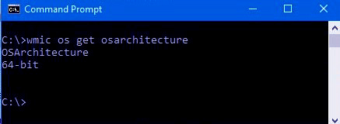](https://d2h0cx97tjks2p.cloudfront.net/blogs/wp-content/uploads/sites/2/2018/04/cmd.jpg)

*Image.1 MongoDB Environment Setup – Know your Windows Architecture*

After executing these commands, you will know if your system is running on 32-bit or 64-bit architecture. Then you have to download the MongoDB setup accordingly.

### b. Download MongoDB Setup File

After knowing the architecture, you have to download the latest version of MongoDB from the official website.

[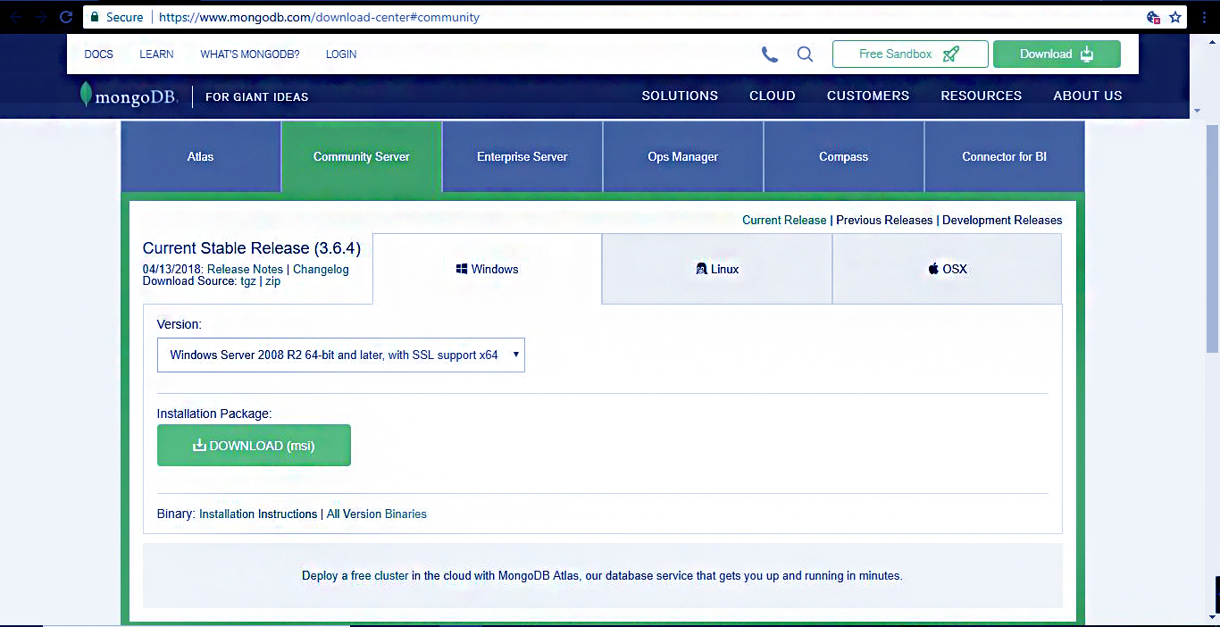](https://d2h0cx97tjks2p.cloudfront.net/blogs/wp-content/uploads/sites/2/2018/04/Capture-2-1.jpg)

*Image.2 MongoDB Environment Setup – Download MongoDB Setup File*

You can follow this link to download from community server of MongoDB.

h[ttps://www.mongodb.org/downloads](https://www.mongodb.org/downloads)

Download the MSI file from this server.

[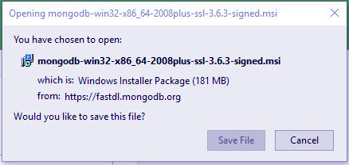](https://d2h0cx97tjks2p.cloudfront.net/blogs/wp-content/uploads/sites/2/2018/04/INSTALLATION-PACKAGE.jpg)

*Image 3. Download MongoDB Setup File*

### c. Install MongoDB Setup

To install MongoDB setup, you need to run the file as administrator. After doing that you need to follow the setup guide that appears in the installation process.

[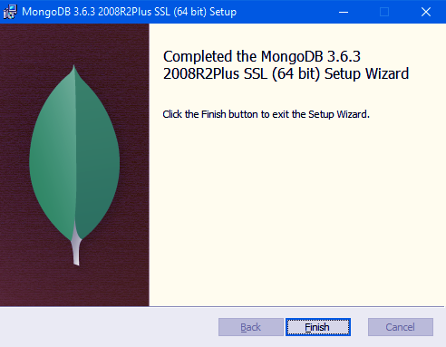](https://d2h0cx97tjks2p.cloudfront.net/blogs/wp-content/uploads/sites/2/2018/04/Screenshot-47-1.png)

*Image. 4 MongoDB Environment Setup – Install MongoDB Setup*

[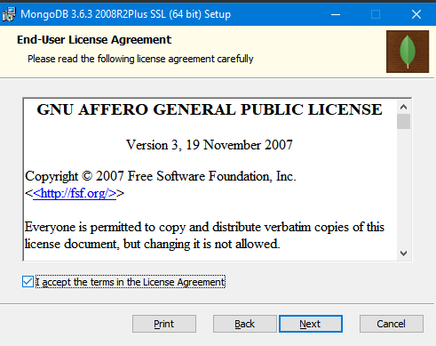](https://d2h0cx97tjks2p.cloudfront.net/blogs/wp-content/uploads/sites/2/2018/04/Screenshot-36-2.png)

*Image. 5 MongoDB Environment Setup – Install MongoDB Setup*

You can choose a custom directory for the MongoDB data and log files. Otherwise, by default, it will install MongoDB to C:\Program Files\MongoDB\Server\3.6\.

MongoDB does not have any system dependency, so it is not problematic to choose any folder in the directory. You can choose any directory in the system.

[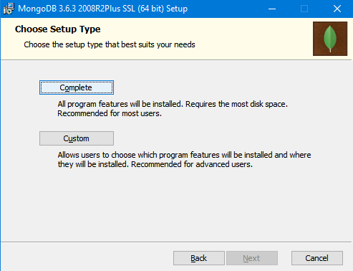](https://d2h0cx97tjks2p.cloudfront.net/blogs/wp-content/uploads/sites/2/2018/04/Screenshot-38.png)

*Image. 6 MongoDB Environment Setup – Install MongoDB Setup*

You will see the option to install MongoDB compass in addition to MongoDB serve and you can check the box if you want it to install MongoDB. If not, leave it blank.

[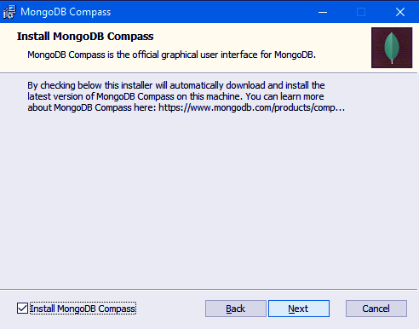](https://d2h0cx97tjks2p.cloudfront.net/blogs/wp-content/uploads/sites/2/2018/04/Screenshot-39-1.png)

*Image. 7 MongoDB Environment Setup – Install MongoDB Setup*

[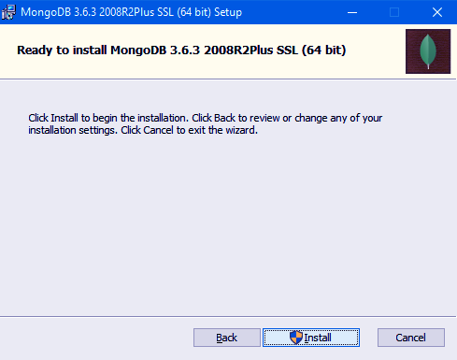](https://d2h0cx97tjks2p.cloudfront.net/blogs/wp-content/uploads/sites/2/2018/04/Screenshot-40-1.png)

*Image. 8 MongoDB Environment Setup – Install MongoDB Setup*

### d. MongoDB Environment Setup

All of MongoDB data is stored in a specified data directory. You need to create it manually in the MongoDB Folder on the C drive. For this, run the following command at the command prompt.

 md \data\db

You can install MongoDB at any location of your choice.

[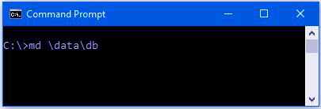](https://d2h0cx97tjks2p.cloudfront.net/blogs/wp-content/uploads/sites/2/2018/04/path.jpg)

*Image. 9 MongoDB Environment Setup*

### e. Start MongoDB

To start MongoDB you need to execute this command. This will start the main MongoDB process. You will see at the bottom of the command prompt a message as “waiting for a connection”. This means that the process has started successfully.

“C:\Program Files\MongoDB\Server\3.6\bin\mongod.exe”

[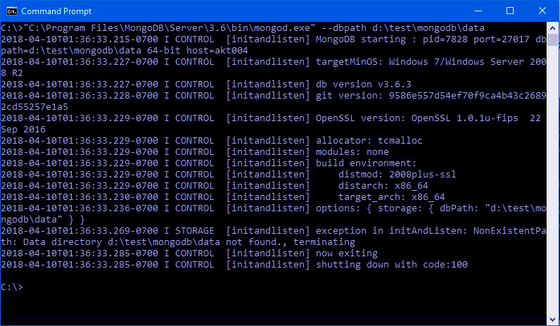](https://d2h0cx97tjks2p.cloudfront.net/blogs/wp-content/uploads/sites/2/2018/04/pathh2.jpg)

*Image. 10 MongoDB Environment Setup – Start MongoDB*

### f. Connect to MongoDB Server

After executing the MongoDB.exe file, the process has begun. Now we need to connect it to the MongoDB server. We will connect it through Mongo.exe shell by opening another command prompt. Now you need to execute a command to connect with the shell.

“C:\Program Files\MongoDB\Server\3.6\bin\mongo.exe”

Now MongoDB is ready to use. You can terminate the running Process of MongoDB by pressing “ctrl+c”.

## Why MongoDB?

As it is a NoSQL database, that’s why it has many reasons to learn MongoDB. These reasons have led the foundation to the worldwide popularity of MongoDB.

These are some reasons, of why MongoDB is popular.

* Aggregation Framework
* BSON Format
* Sharding
* Ad-hoc Query
* Capped Collection
* Indexing
* File Storage
* Replication
* MongoDB Management Service (MMS)

[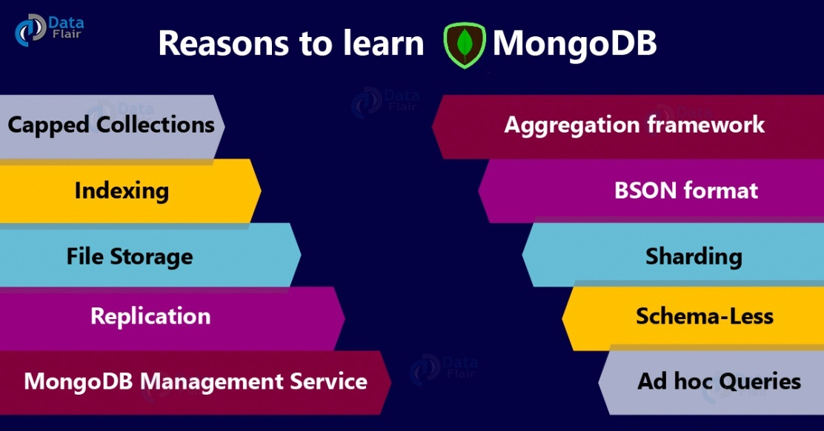](https://d2h0cx97tjks2p.cloudfront.net/blogs/wp-content/uploads/sites/2/2019/01/Reasons-to-learn-MongoDB-01.jpg)

*Top Reasons to learn MongoDB*

### i) Aggregation framework

We can use it in a very efficient manner by MongoDB. **[MapReduce](https://data-flair.training/blogs/hadoop-mapreduce-tutorial/)** can be used for batch processing of data and also for aggregation operations. MapReduce is nothing but a process, in which large datasets will process and generate results with the help of parallel and distributed algorithms on clusters.

It consists of two sets of operations in itself, they are: Map() and Reduce().

* **Map():** It performs operations like filtering the data and then performing sorting on that dataset.
* **Reduce():** It performs the operation of summarizing all the data after the map() operation.

[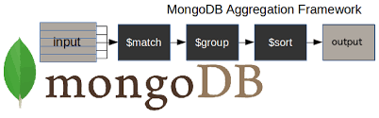](https://d2h0cx97tjks2p.cloudfront.net/blogs/wp-content/uploads/sites/2/2019/01/Why-mongoDB-1.png)

*Aggregation Framework*

#### ii) BSON format

It is JSON-like storage a format. **BSON stands for Binary JSON**. BSON is binary-encoded serialization of JSON like [**documents**](https://data-flair.training/blogs/mongodb-update-document/) and MongoDB uses it, when to stores documents in collections. We can add data types like date and binary (JSON doesn’t support).

BSON format makes use of _id as a primary key over here. As stated that _id is being used as a primary key so it is having a unique value associated with itself called as ObjectId, which is either generated by application driver or MongoDB service. Below is an example to understand BSON format in a more better way:

**Example-**

1. {
2. "_id": **ObjectId**("12e6789f4b01d67d71da3211"),
3. "title": "Key features Of MongoDB",
4. "comments": [
5. ...
6. ]
7. }

Another advantage of using BSON format is that it enables to internally index and map document properties. As it is designed to be more efficient in size and speed, it increases the read/write throughput of MongoDB.

#### iii. Sharding

The major problem with any web/mobile application is scaling. To overcome this MongoDB has added sharding feature. It is a method in which, data is being distributed across multiple machines. Horizontal scalability is being provided with the sharding.

It is a complicated process and is done with the help of several shards. Each shard holds some part of data and functions as a separate [**database**](https://data-flair.training/blogs/mongodb-create-database/). Merging all the shards together forms a single logical database. Operations over here are being performed by query routers.

#### iv. Ad hoc queries

MongoDB supports range query, regular expression and many more types of searches. Queries include user-defined Javascript functions and it can also return specific fields from the documents. MongoDB can support ad hoc queries by using a unique query language or by indexing BSON documents.

Let’s see the difference between SQL SELECT query and resembling query:

E.g. Fetching all records of student table with student name like ABC.

* **SQL Statement –** SELECT * FROM Students WHERE stud_name LIKE ‘%ABC%’;
* **MongoDB Query –** db.Students.find({stud_name:/ABC/ });

#### v. Schema-Less

As it is a schema-less database(written in C++), it is much more flexible than the traditional database. Due to this, the data does not require much to set up for itself and reduced friction with OOP. If you want to save an object, then just serialize it to JSON and send it to MongoDB.

#### vi. Capped Collections

MongoDB supports capped collection, as it is having fixed [**size of collections**](https://data-flair.training/blogs/mongodb-create-collection/) in it. It maintains the insertion order. Once the limit is reached it starts behaving like a circular queue.

Example – Limiting our capped collection to 2MB

* db.createCollection(’logs’, {capped: true, size: 2097152})

#### viii. Indexing

To improve the performance of searches[**indexes are being created**](https://data-flair.training/blogs/mongodb-index/). We can index any field in MongoDB document either primary or secondary.

Due to this reason, the database engine can efficiently resolve queries.

[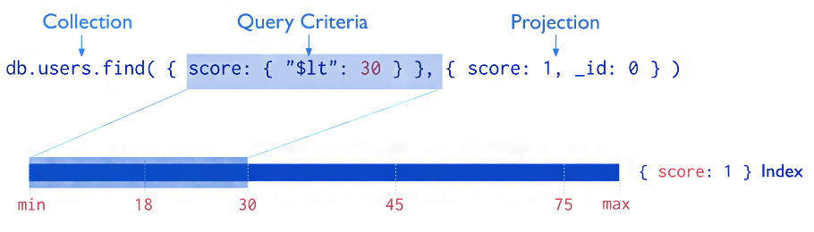](https://d2h0cx97tjks2p.cloudfront.net/blogs/wp-content/uploads/sites/2/2019/01/Why-mongoDB-2.png)

*Indexing*

#### viii. File Storage

MongoDB can also be used as a file storing system, which avoids load imbalance and also data replication. This function performed with the help of **Grid File System**, it is included in drivers which stores files.

[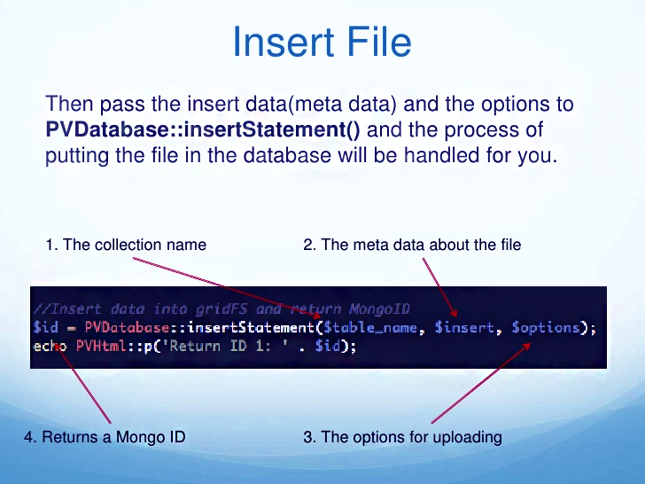](https://d2h0cx97tjks2p.cloudfront.net/blogs/wp-content/uploads/sites/2/2019/01/Why-mongoDB-3.png)

*File Storage in MongoDB*

#### ix. Replication

Replication is being provided by distributing data across different machines. It can have one primary node and more than one secondary nodes in it (replica set). This set acts like a master-slave. Here, a master can perform read and write and a slave copies data from a master as a backup only for a read operation.

[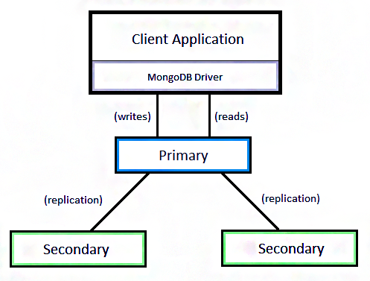](https://d2h0cx97tjks2p.cloudfront.net/blogs/wp-content/uploads/sites/2/2019/01/Why-mongoDB-4.png)

*Replication*

#### x. MongoDB Management Service (MMS)

MongoDB has a very powerful feature of MMS, due to which we can track our databases or machines and if needed can backup our data. It also tracks hardware metrics for managing the deployment. It provides a feature of custom alert, due to which we can discover issues before our MongoDB instance will affect.

[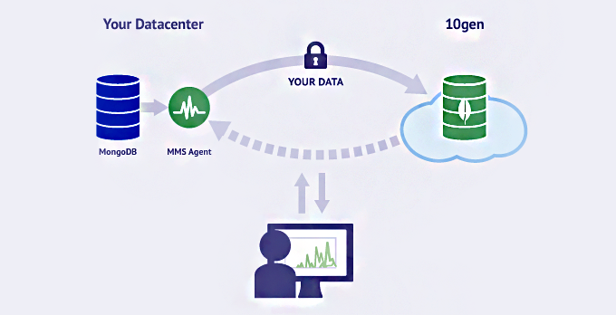](https://d2h0cx97tjks2p.cloudfront.net/blogs/wp-content/uploads/sites/2/2019/01/Why-mongoDB-5.png)

*MongoDB Management Service (MMS)*

## 2. Benefits of MongoDB

This is the**second phase of Why MongoDB, advantages.**

#### i. Load Balancing

If you are having a large set of data that you need to process then you can distribute the traffic amongst different machines with the help of load balancing. It helps the user in a way that you can continue your work even if one of the nodes/machines has stopped working due to some reason. The other nodes will keep the work in a continuation and your processing will not stop.

[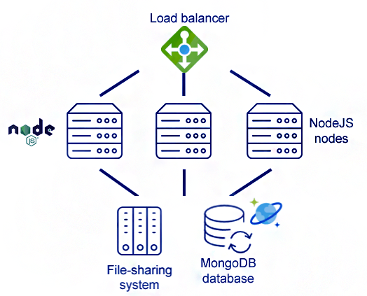](https://d2h0cx97tjks2p.cloudfront.net/blogs/wp-content/uploads/sites/2/2019/01/Why-mongoDB-6.png)

*Load Balancing*

#### ii. Sharding

With the help of sharding, we can do horizontal scaling. Which is not possible with the help of a relational database. By using this method, we can distribute data across different machines. We make shards of the data that we are having with ourselves and then we try to make the processing task a bit easy.

[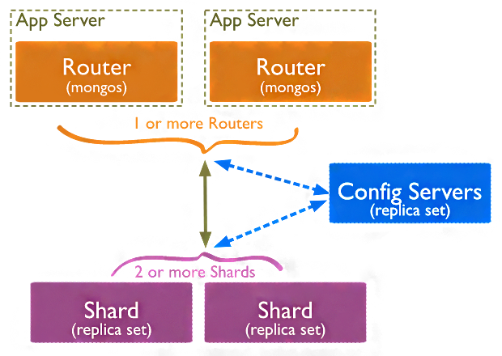](https://d2h0cx97tjks2p.cloudfront.net/blogs/wp-content/uploads/sites/2/2019/01/Why-mongoDB-7.png)

*Sharding in MongoDB*

#### iii. Flexibility

It does not require data structures, that are unified in nature across all the objects that are being used. This makes it easier to use MongoDB. With the help of dynamic schema, it is very easy to use MongoDB.

[](https://d2h0cx97tjks2p.cloudfront.net/blogs/wp-content/uploads/sites/2/2019/01/Why-mongoDB-8.png)

*Flexibility*

#### iv. Speed

MongoDB can fast and easy process the data. But this is valid up to your data is in document format. We can say that it’s speed automatically increases as it is handling a large amount of unstructured data within seconds which feels like magic.

[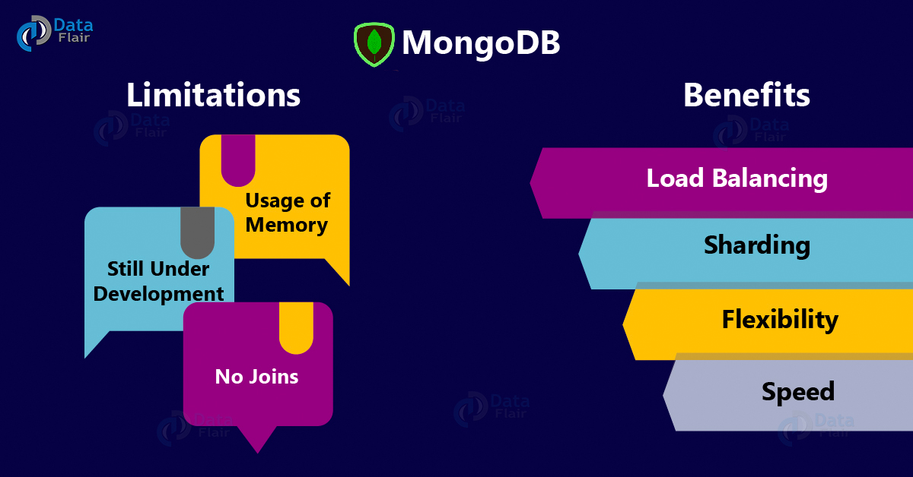](https://d2h0cx97tjks2p.cloudfront.net/blogs/wp-content/uploads/sites/2/2019/01/MongoDB-Benefits-and-Limitations-01.jpg)

## 4. Drawbacks/Limitations of MongoDB

This is the**third phase of Why MongoDB**, limitations.

#### i. Usage of Memory

As we know that [MongoDB stores](https://en.wikipedia.org/wiki/MongoDB) the key name along with every document so it is obvious that it will consume a large amount of memory. And as joins are also not possible so it becomes very difficult to work with duplicate data.

[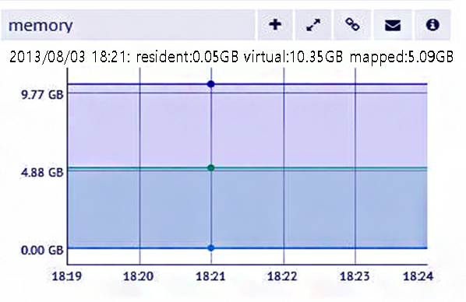](https://d2h0cx97tjks2p.cloudfront.net/blogs/wp-content/uploads/sites/2/2019/01/Why-mongoDB-10.png)

*Usage of Memory*

#### ii. No Joins

As we apply joins very easily in the relational database very easily, it is not possible to apply joins in MongoDB. So if you want to apply joins in it, then you will have to write many complex queries to perform join operation over here.

#### iii. Still Under Development

[**SQL was developed**](https://data-flair.training/blogs/sql-tutorial/) in the 1980s, and **MongoDB** just emerged in 2009. So due to this reason, MongoDB is not yet fully documented or tested and does not have total support from the experts of it.